Application Form
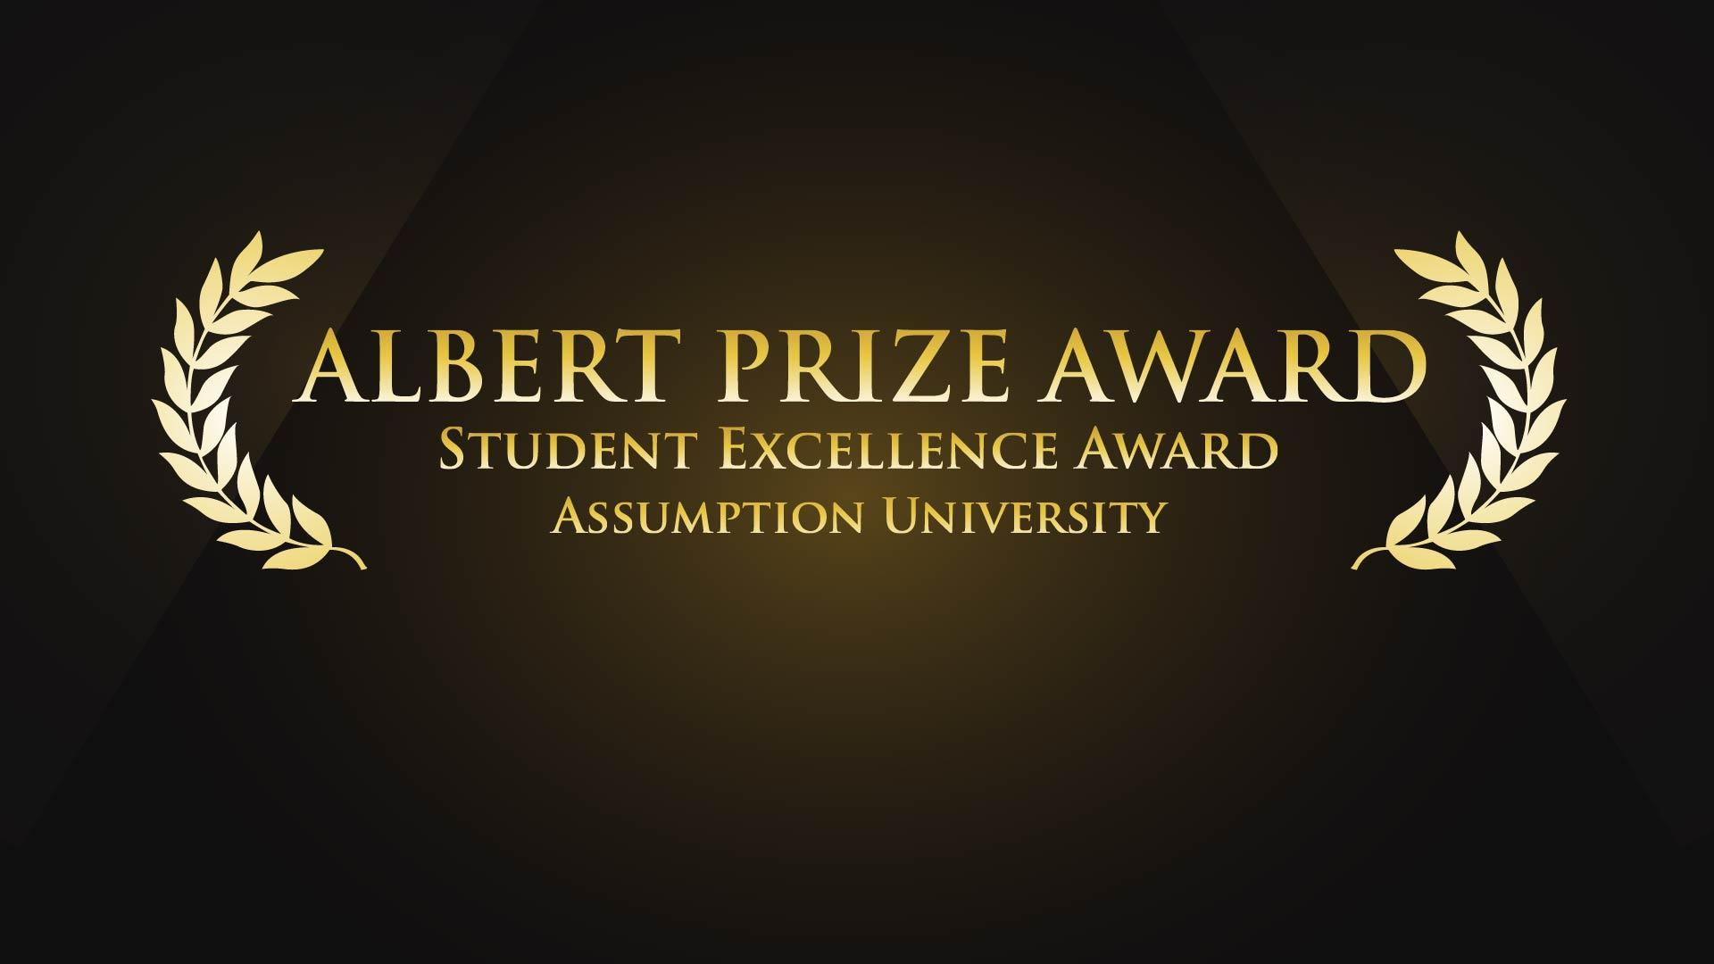

Category I Award of the year
7. MC of the Year

Applicant photo

Name-Surname (Mr./Ms.) __________________________________________________

Category I: 7.MC of the Year
1. Basic Information

(1.1) Applicant

Name-Surname (Mr./Ms.) _________________________________________________

ID. No. _____________ Faculty ______________________________________________

Major ______________________________________ Year _____________GPA. _______

Credit completed _______Credits Nationality _____________________________

Ethnic____________ Religion__________________ Contact No. __________________

E-mail _________________________________ Line ID. __________________________

My Motto is _______________________________________________________________

(1.2) Recommender

(Dean /Student Activity Coordinator of Faculty/ Student Activity’s advisor)

Name-Surname (Mr./Ms.) _________________________________________________

Position ______________ Contact No. ______________ E-mail __________________

(1.3) Experiences / Activity Profiles (Past – Present)

_________________________________________________________________________________

_________________________________________________________________________________

_________________________________________________________________________________

_________________________________________________________________________________

_________________________________________________________________________________

(1.4) Description of Achievements

_________________________________________________________________________________

_________________________________________________________________________________

_________________________________________________________________________________

_________________________________________________________________________________

_________________________________________________________________________________

Category I: 7.MC of the Year

2. (For applicant) Please list your outstanding activity performance e.g.
awards, participation in major events etc., and provide support
evidences (photo, certificate, invitation letter etc.)

(2.1) Contest and Competition events
Activity’s name | Detail of activity | Award / Result  and Organizer | Date and Venue
National / International Level
Institution Level

(2.2) Non-Contest and Non-Competition events
Activity’s name | Detail of activity | Award / Result  and Organizer | Date and Venue

Category I: 7.MC of the Year

3. (For recommender) Please describe outstanding performance of the applicant as being a master of ceremony according to the following characteristics

3.1 Skill and knowledge (effective communicate of messages delivery, ability to solicit audience, control the situation)
________________________________________________________________________________

________________________________________________________________________________

________________________________________________________________________________

________________________________________________________________________________

________________________________________________________________________________

________________________________________________________________________________

________________________________________________________________________________

________________________________________________________________________________

________________________________________________________________________________

________________________________________________________________________________

________________________________________________________________________________

3.2 English Proficiency (Use proper formality of language)

________________________________________________________________________________

________________________________________________________________________________

________________________________________________________________________________

________________________________________________________________________________

________________________________________________________________________________

________________________________________________________________________________

________________________________________________________________________________

________________________________________________________________________________

________________________________________________________________________________

________________________________________________________________________________

Category I: 7.MC of the Year

3.3 Personality (Professional dress, express of body language, smile, eye contact)

________________________________________________________________________________

________________________________________________________________________________

________________________________________________________________________________

________________________________________________________________________________

________________________________________________________________________________

________________________________________________________________________________

________________________________________________________________________________

________________________________________________________________________________

3.4 Involvement in student activity and university activity / recognition among
students and AU community

________________________________________________________________________________

________________________________________________________________________________

________________________________________________________________________________

________________________________________________________________________________

________________________________________________________________________________

________________________________________________________________________________

________________________________________________________________________________

________________________________________________________________________________

Signature_______________________________ (Recommender)
(_______________________________)
Position _____________________________________
From ________________________________________
Contact No. _________________________________
____ / _____ /_____

Required documents:

- Printed
1. Application Form
2. Copies of document related to the performance of being a master of ceremony
e.g. certificate, invitation letter etc.
3. Pictures while you are performing the role of master of ceremony

- CD
1. High quality of Photo file at least 4 – 5 pictures.
2. VDO presentation (not longer than 2 minutes) that consist
of self-introduction as well as the experience of being a master of ceremony
both internal and external campus.
3. PDF files of application form and copies of document related to the performance
of being a master of ceremony e.g. certificate, invitation letter etc.
4. Pictures while you are performing the role of master of ceremony

Place for Submission:
Center for Student Leadership and Experiential Learning (CSLEL) office, the ground floor of King David Resident Hall
Tel. 02-723-2222 Ext. 7292

***All applicants must submit the required documents at CSLEL office and in case of any correction, please notify us by sending email to sa.cslel@au.edu***

